Annual Report According to the Article 8 (2) of Council Common Position 2008/1944/CFSP defining Common Rules governing Control of Exports of Military Technology and Equipment

NATIONAL REPORT OF FINLAND FOR 2010

1. REPORTING PERIOD AND SCOPE

Reporting period is the year 2010, 1.1.-31.12.2010. This report covers commercial
exports by the Finnish defence industry authorised under the Act on the Export and
Transit of Defence Materiel (defence material).

2. LEGAL BASIS AND NATIONAL LICENSING GUIDELINES

The basic principles, policies and national practices on the export, transit and arms
brokering of conventional arms and related technology are outlined in the relevant
Finnish legislation. The export of defence materiel and its transit is allowed only if
authorisation (an export licence) has been granted. Provisions on controlling arms
brokering are incorporated into the Act on the Export and Transit of Defence Materiel.
The guiding principle is simple; the same controls apply to brokering as apply to export
and transit of defence materiel. Authorisation for export, transit or arms brokering will
not be granted if it jeopardises Finland’s security or is in contradiction with Finland’s
foreign policy.

These basic principles contained in the Act on the Export and Transit of Defence Materiel
are supplemented by clarifying rules outlined in the national Guidelines. All applications
are examined on a case-by-case basis based on an overall assessment. The following
factors shall be taken into account in the overall assessment of licence applications:

- foreign and security policy aspects, including the relevant UN, OSCE, EU and other
international obligations be they decisions on arms embargoes, multilateral
restraints, criteria, principles or guidelines of multilateral export control regimes
- an analysis of the situation prevailing in the recipient country, especially with
regard to human rights, including attitudes of other States vis-à-vis the recipient
country
- the characteristics, intended use and military significance of the item to be
exported
- the significance of the item and export in relation to the materiel preparedness of
Finnish national defence and to the development of domestic defence industry.

The EU Code of Conduct on Arms Exports is incorporated into the Finnish legislation as
an annex to the national Guidelines. In ambiguous cases, a restrictive approach is
preferred. If the export of the item in question, by virtue of its characteristics and
significance, will not lead to, or in all likelihood will not to be used in violations of human
rights, offensive armed action or other comparable unacceptable purposes inside or
outside the recipient country, the granting of a licence may be recommended if the
overall assessment on all other accounts is favourable and if the formal licensing
requirements have been met. There are specific rules for the export licensing of
components and sub-systems of any defence equipment.

Legislation on arms brokering came into force in Finland on December 1st, 2002.
Provisions on controlling arms brokering were incorporated into the Act on the Export
and Transit of Defence Materiel. Finnish legislation is in full compliance with the Common
Position on arms brokering adopted by Council of the European Union in June 2003. The
provisions on arms brokering also implement the provisions of the UN Firearms Protocol
and the OSCE Document on Small Arms and Light Weapons as well as the norms set out
in the UN Programme of Action on Small Arms and Light Weapons.

The Ministry of Defence (MoD) maintains a database of all licences granted. The licences
are public documents in Finland and available for reading or photocopying at the MoD
registry. The MoD publishes detailed statistics of all licences granted on an annual basis.

The relevant Finnish legislation is as follows:

Act on the Export and Transit of Defence Materiel (242/1990)

- a concise framework law stipulating the authorisation and procedure as well as
sanctions in case of violations
- establishes the following responsibilities for various authorities:

1. Ministry of Defence (MoD): licensing authority
2. Council of State (Council of Ministers): grants licences for all major
exports; affirms the guidelines
3. Ministry for Foreign Affairs (MFA): advises on foreign and security policy
considerations
4. Customs: enforcement

General Guidelines for the Export and Transit of Defence Materiel (1000/2002)

- Provides more detailed guidelines for the application of the Act by giving clarifying rules
of foreign and security policy substances as well as of procedural substance
- Provides more detailed guidelines for the implementation of the international
agreements and obligations adhered to by Finland in the field of export of defence
equipment
- Incorporates the international no arms into the domestic legislation by explicit references
to the OSCE Principles on arms transfers, the EU Code of Conduct on Arms Exports,
decisions on arms embargoes by the UNSC or the EU etc. and integrates these sets to
the Guidelines as its annexes.

Decree on the Export and Transit of Defence Materiel (108/1997)

- establishes the coverage of controls by defining the list of defence materiel, by main
headings, classified into four item categories (based on characteristics, intended use and
military significance of the items)
- the coverage also includes “related technology”. Authorisation is, hence, needed for
yielding control or transfer abroad of any:

- know-how and licence to manufacture materiel
- machine tools and equipment especially designed for manufacturing materiel
- computer software relating to the manufacture or use of materiel
- the export of technology shall require an export licence even if such technology is
intended for development, production or use of an item which is not defined as
defence materiel

- authorisation is not required for the exports of technology which is necessary for the
installation, use, maintenance, inspection, or repair of an already licensed item
- nor is authorisation required for the export of technology which is widely available
internationally or related to basic scientific research.

Decree of the Ministry of Defence (192/1997)

- implements the EU Common List of Military Equipment as well as the Munitions’ List
of the Wassenaar Arrangement.

3. EXPORT LICENCES OF DEFENCE MATERIEL IN 2010¹

Country of destination | ML Category² | Number of licenses | Total amount (kg/m/pcs) | Unit | Total value of licences granted by destination (EUR)
Afganistan* | ML8a | 1 | 7 000 | kg
 |  |  | 40 000 | m
 |  |  | 39 000 | pcs | 198 780,00
Albania | ML3a | 1 | 17 000 | pcs | 49 600,00
Argentina | ML1a | 1 | 40 | pcs
 | ML7f | 2 | 533 | pcs | 102 650,00
Australia | ML1a | 2 | 250 | pcs
 | ML1d | 2 | 26 | pcs
 | ML3a | 2 | 1 100 760 | pcs
 | ML7f | 9 | 2 815 | pcs
 | ML13c | 1 | 71 | pcs
 | ML13d | 1 | 28 | pcs | 1 490 594,90
Austria | ML1d | 1 | 3 | pcs
 | ML3a | 1 | 300 000 | pcs
 | ML13c | 2 | 146 | pcs
 | ML13d | 2 | 103 | pcs | 351 259,00
Bahrain | ML1a | 1 | 205 | pcs | 872 000,00
Belgium | ML3a | 1 | 300 000 | pcs
 | ML7f | 3 | 150 | pcs
 | ML13c | 1 | 71 | pcs
 | ML13d | 2 | 1 028 | pcs
 | ML21b | 1 | 1 | pcs
 | ML22 | 1 | 12 | pcs | 1 221 111,00
Brazil | ML3a | 1 | 55 000 | pcs
 | ML7f | 1 | 3 | pcs | 52 250,00
Bulgaria | ML1a | 1 | 50 | pcs
 | ML13c | 1 | 71 | pcs
 | ML13d | 1 | 28 | pcs | 242 455,00
Canada | ML1d | 2 | 17 | pcs
 | ML3a | 1 | 1 100 000 | pcs
 | ML13c | 1 | 71 | pcs
 | ML13d | 1 | 28 | pcs | 910 787,00
Chad* | ML13d | 1 | 4 | pcs | 2 832,00
Chile | ML7f | 3 | 406 | pcs | 9 759,25
Congo* | ML8 | 1 | 7 000 | kg
 |  |  | 40 000 | m
 |  |  | 39 000 | pcs | 198 780,00
Croatia | ML1a | 1 | 2 | pcs
 | ML6a | 1 | 39 551 | pcs
 | ML7f | 1 | 66 | pcs | 4 511 100,50
Cyprus | ML13c | 1 | 71 | pcs
 | ML13d | 1 | 28 | pcs | 29 205,00
Czech Republic | ML1 | 2 | 120 | pcs
 | ML3a | 2 | 230 000 | pcs
 | ML4a | 1 | 68 | pcs
 | ML6a | 1 | 433 274 | pcs
 | ML13c | 1 | 71 | pcs
 | ML13d | 1 | 28 | pcs | 1 101 960,83
Denmark | ML1a | 1 | 100 | pcs
 | ML1d | 2 | 14 | pcs
 | ML3a | 1 | 900 000 | pcs
 | ML13c | 2 | 371 | pcs
 | ML13d | 3 | 628 | pcs | 1 696 866,00
Ecuador | ML7f | 1 | 1 620 | pcs | 47 000,00
Egypt | ML1a | 1 | 2 | pcs | 6 000,00
Estonia | ML1a | 1 | 40 | pcs
 | ML3a | 2 | 120 000 | pcs
 | ML4a | 2 | 1 145 | pcs
 | ML6a | 2 | 22 994 | pcs
 | ML7f | 1 | 273 | pcs
 | ML8a | 2 | 40 | kg
 |  |  | 6 | pcs
 | ML13c | 1 | 71 | pcs
 | ML13d | 1 | 28 | pcs | 1 384 512,26
France | ML1d | 2 | 35 | pcs
 | ML3a | 1 | 900 000 | pcs
 | ML4a | 1 | 17 | pcs
 | ML7f | 3 | 42 | pcs
 | ML8a | 10 | 73 231 | kg
 | ML 13c | 2 | 1 676 | pcs
 | ML13d | 4 | 328 | pcs
 | ML15d | 1 | 24 | pcs | 3 305 948,70
France (New Caledonia) | ML1a | 1 | 10 | pcs | 17 700,00
Germany | ML1a | 1 | 200 | pcs
 | ML2a | 1 | 600 | pcs
 | ML3a | 2 | 155 000 | pcs
 | ML7f | 2 | 10 002 | pcs
 | ML13c | 1 | 71 | pcs
 | ML13d | 1 | 28 | pcs
 | ML21a | 1 | 1 | pcs
 | ML22a | 1 | 1 | pcs | 2 170 257,00
Greece | ML3a | 1 | 100 000 | pcs
 | ML13c | 1 | 71 | pcs
 | ML13d | 1 | 28 | pcs | 108 205,00
Hungary | ML3a | 1 | 100 000 | pcs
 | ML13c | 2 | 146 | pcs
 | ML13d | 2 | 228 | pcs | 332 205,00
Iceland | ML3a | 1 | 100 000 | pcs
 | ML13c | 1 | 71 | pcs
 | ML13d | 1 | 28 | pcs | 108 205,00
India | ML11a | 1 | 2 | pcs
 | ML13 | 1 | 13 | pcs | 6 190,00
Iraq | ML11a | 1 | 126 | pcs | 945 000,00
Ireland | ML1a | 1 | 200 | pcs
 | ML3a | 2 | 450 000 | pcs
 | ML13c | 1 | 71 | pcs
 | ML13d | 1 | 28 | pcs | 740 705,00
Israel | ML11a | 1 | 2 | pcs | 7 930,00
Italy | ML1a | 1 | 180 | pcs
 | ML1d | 2 | 9 | pcs
 | ML3a | 3 | 1 255 000 | pcs
 | ML4a | 1 | 100 | pcs
 | ML7e1 | 1 | 150 | pcs
 | ML13a | 2 | 5 690 | pcs
 | ML13c | 1 | 71 | pcs
 | ML13d | 1 | 28 | pcs | 1 159 498,00
Japan | ML3a | 1 | 700 000 | pcs
 | ML13c | 1 | 71 | pcs
 | ML13d | 1 | 28 | pcs | 582 205,00
Jordan | ML1a | 1 | 25 | pcs
 | ML13d | 1 | 4 | pcs | 135 232,00
Kosovo* | ML7f | 1 | 90 | pcs | 3 045,00
Kuwait | ML1a | 1 | 3 | pcs
 | ML15d | 1 | 70 | pcs | 520 000,00
Latvia | ML3a | 1 | 100 000 | pcs
 | ML13c | 1 | 71 | pcs
 | ML13d | 1 | 28 | pcs | 108 205,00
Lebanon | ML3a | 1 | 20 000 | pcs | 51 000,00
Lithuania | ML1a | 1 | 100 | pcs
 | ML7f | 1 | 1 720 | pcs
 | ML13c | 1 | 71 | pcs
 | ML13d | 1 | 28 | pcs | 149 240,00
Luxembourg | ML3a | 1 | 400 000 | pcs
 | ML13c | 1 | 71 | pcs
 | ML13d | 1 | 28 | pcs | 345 205,00
Malaysia | ML7f | 1 | 12 200 | pcs
 | ML10 | 1 | 1 | pcs | 478 169,03
Malta | ML13c | 1 | 71 | pcs
 | ML13d | 1 | 28 | pcs | 29 205,00
Mexico | ML 1a | 1 | 51 | pcs | 130 000,00
Namibia | ML1a | 1 | 200 | pcs | 377 500,00
Netherlands | ML1a | 2 | 50 | pcs
 | ML3a | 2 | 205 100 | pcs
 | ML13c | 1 | 71 | pcs
 | ML13d | 1 | 28 | pcs | 300 879,81
New Zealand | ML 1a | 1 | 185 | pcs
 | ML3a | 1 | 450 000 | pcs
 | ML13c | 1 | 71 | pcs
 | ML13d | 1 | 28 | pcs | 684 705,00
Norway | ML1a | 3 | 401 | pcs
 | ML1d | 1 | 4 | pcs
 | ML3a | 4 | 2 352 100 | pcs
 | ML7e1 | 1 | 12 | pcs
 | ML13c | 1 | 71 | pcs
 | ML13d | 1 | 28 | pcs | 3 021 705,40
Pakistan* | ML13c | 1 | 55 | pcs
 | ML13d | 1 | 55 | pcs | 61 600,00
Poland | ML3a | 1 | 600 000 | pcs
 | ML7f | 2 | 36 | pcs
 | ML10 | 1 | 3 | pcs
 | ML13c | 1 | 71 | pcs
 | ML13d | 1 | 28 | pcs | 1 240 211,00
Portugal | ML1a | 1 | 350 | pcs
 | ML3a | 1 | 30 000 | pcs
 | ML7f | 1 | 7 | pcs
 | ML13c | 1 | 71 | pcs
 | ML13d | 1 | 28 | pcs | 597 731,50
Romania | ML3a | 3 | 18 060 | pcs
 | ML7f | 1 | 70 | pcs
 | ML13c | 1 | 71 | pcs
 | ML13d | 1 | 28 | pcs | 93 843,50
Russia | ML1a | 3 | 282 | pcs | 422 750,00
Saudi Arabia | ML1d | 1 | 271 | pcs
 | ML7f | 2 | 12 100 | pcs
 | ML11a | 4 | 34 | pcs | 1 281 722,00
Slovakia | ML3a | 1 | 350 000 | pcs
 | ML7e1 | 1 | 120 | pcs
 | ML13c | 1 | 71 | pcs
 | ML13d | 1 | 28 | pcs | 311 522,00
Slovenia | ML2a | 1 | 120 | pcs
 | ML3a | 1 | 100 000 | pcs
 | ML7f | 1 | 4 000 | pcs
 | ML13c | 1 | 71 | pcs
 | ML13d | 1 | 28 | pcs | 188 005,00
Somalia* | ML8 | 1 | 7 000 | kg
 |  |  | 40 000 | m
 |  |  | 39 000 | pcs | 198 780,00
South Africa | ML1a | 1 | 100 | pcs
 | ML3a | 1 | 200 | pcs
 | ML6a | 1 |  | pcs
 | ML21 | 1 | 1 | pcs | 707 040,00
South Korea | ML3a | 2 | 20 566 | pcs
 |  |  | 50 000 | kg
 | ML11a | 1 | 2 | pcs | 205 000,00
Spain | ML1a | 1 | 350 | pcs
 | ML3a | 7 | 1 065 460 | pcs
 | ML7f | 2 | 520 | pcs
 | ML13c | 1 | 71 | pcs
 | ML13d | 2 | 258 | pcs | 1 564 506,20
Sudan* | ML8 | 1 | 7 000 | kg
 |  |  | 40 000 | m
 |  |  | 39 000 | pcs
 | ML13c | 1 | 21 | pcs
 | ML13d | 1 | 21 | pcs | 218 016,00
Sweden | ML3a | 8 | 17 003 225 | pcs
 | ML4a | 1 | 803 | pcs
 | ML8 | 1 | 84 | pcs
 | ML13c | 1 | 71 | pcs
 | ML13d | 1 | 28 | pcs | 4 342 521,00
Switzerland | ML1a | 2 | 221 | pcs
 | ML1d | 1 | 6 | pcs
 | ML3a | 1 | 350 000 | pcs
 | ML7f | 1 | 50 | pcs
 | ML13c | 3 | 541 | pcs
 | ML13d | 3 | 498 | pcs | 1 071 245,50
Taiwan | ML7 | 1 | 6 | pcs | 7 500,00
Thailand | ML3a | 2 | 18 050 | pcs
 | ML7f | 3 | 624 | pcs
 | ML11a | 3 | 18 | pcs | 169 713,00
Tunisia | ML11a | 1 | 1 | pcs | 11 210,00
Turkey | ML3a | 1 | 42 000 | pcs
 | ML11a | 3 | 6 | pcs | 85 290,00
Ukraine | ML1d | 1 | 5 | pcs
 | ML7e1 | 1 | 16 | pcs
 | ML11a | 2 | 6 | pcs | 62 240,00
United Arab Emirates | ML1a | 1 | 1 | pcs
 | ML7f | 3 | 22 | pcs
 | ML11a | 3 | 11 | pcs
 | ML15c | 1 | 2 | pcs | 202 300,00
United Kingdom | ML3a | 4 | 1 171 480 | pcs
 | ML7f | 1 | 30 000 | pcs
 | ML13c | 1 | 71 | pcs
 | ML13d | 1 | 28 | pcs | 1 120 405,00
United States | ML1a | 2 | 10 011 | pcs
 | ML3a | 1 | 4 900 000 | pcs
 | ML4a | 1 | 415 | pcs
 | ML7f | 7 | 23 025 | pcs
 | ML10c2 | 1 | 1 | pcs
 | ML13a | 1 | 1 000 | pcs
 | ML13c | 2 | 121 | pcs
 | ML13d | 2 | 78 | pcs | 16 512 856,66
West Sahara* | ML8 | 1 | 7 000 | kg
 |  |  | 40 000 | m
 |  |  | 39 000 | pcs | 198 780,00
Vietnam | ML11a | 1 | 1 | pcs | 2 200,00
Yemen* | ML13c | 1 | 40 | pcs
 | ML13d | 1 | 40 | pcs | 44 800,00
TOTAL |  | 341³ | 38 262 301 | pcs | 61 219 431,04

*For United Nations mandated or other international missions

1. N.B. Figures given under this item only include export licences granted in 2010 for commercial
exports by the Finnish defence industry. Figures above do not include uncommercial exports
for the Finnish Defence Forces' purposes, temporary export licences, transit licences nor responses to prior enquiries.
2. See p.20 for brief descriptions of EU Common Military List categories.
3. This number includes four (4) general licences which each concern several countries of destination. Due to the statistical representation of showing licences by country of destination, this number seems higher than the actual number of licences granted (237 pcs).
4. ACTUAL EXPORTS OF DEFENCE MATERIEL 2010

Country of  destination | ML  Category | Definition of material | Value/category  by destination | Total value of  arms exports  by destination  (EUR) | Share of  total exports  (%)
Albania | ML3a | Ammunition, shots etc and components therefore | 53 450,00 € | 53 450,00 € | 0,09 %
Argentina | ML1a | Sniper rifles and accesories | 9 895,00 €
 | ML7f | Protective and decontamination equipment | 42 957,00 € | 52 852,00 € | 0,09 %
Australia | ML1a | Sniper rifles and accesories | 1 777,00 €
 | ML3a | Ammunition, shots etc and components therefore | 65 199,20 €
 | ML7f | Protective and decontamination equipment | 6 984,75 €
 | ML11a | Electronic equipment specially designed for military use | 81 960,00 € | 155 920,95 € | 0,27 %
Austria | ML3a | Ammunition, shots etc and components therefore | 7 638,40 € | 7 638,40 € | 0,01 %
Belgium | ML1a | Sniper rifles and accesories | 146 705,00 €
 | ML3a | Ammunition, shots etc and components therefore | 17 255,00 €
 | ML7f | Protective and decontamination equipment | 2 524,50 €
 | ML21 | Software specially designed for military use | 131 608,00 € | 298 092,50 € | 0,51 %
Brazil | ML3a | Ammunition, shots etc and components therefore | 52 250,00 € | 52 250,00 € | 0,09 %
Canada | ML1a | Sniper rifles and accesories | 106 783,00 €
 | ML1d | Silencers and accesories | 36 000,00 €
 | ML3a | Ammunition, shots etc and components therefore | 14 320,86 €
 | ML4b | Equipment for handling explosivedevices and related items | 157 114,70 € | 314 218,56 € | 0,53 %
Chad* | ML13d | Protective equipment | 2 832,00 € | 2 832,00 € | 0,00 %
Congo* | ML13d | Protective equipment | 10 610,00 € | 10 610,00 € | 0,02 %
Croatia | ML6a | Military vehicles | 10 163 811,10 €
 | ML7f | Protective and decontamination equipment | 21 098,35 € | 10 184 909,45 € | 17,33 %
Czech Republic | ML1a | Sniper rifles and accesories | 18 950,00 €
 | ML3a | Ammunition, shots etc and components therefore | 2 577,30 €
 | ML4a | Equipment for handling explosivedevices and related items | 95 744,00 € | 117 271,30 € | 0,20 %
Denmark | ML1d | Silencers and accesories | 3 290,00 €
 | ML3a | Ammunition, shots etc and components therefore | 258 350,00 €
 | ML13d | Protective equipment | 41 438,00 € | 303 078,00 € | 0,52 %
Ecuador | ML7f | Protective and decontamination equipment | 75 520,00 € | 75 520,00 € | 0,13 %
Egypt | ML2a | Smooth-bore weapons and components therefore | 11 750,00 € | 11 750,00 € | 0,02 %
Estonia | ML1a | Sniper rifles and accesories | 4 915,00 €
 | ML4a | Bombs, torpedoes, rockets, missiles,other explosive devices and charges | 11 340,00 €
 | ML7f | Protective and decontamination equipment | 292,26 €
 | ML11a | Electronic equipment specially designed for military use | 143 200,00 € | 159 747,26 € | 0,27 %
France | ML1a | Sniper rifles and accesories | 68 874,00 €
 | ML1d | Silencers and accesories | 8 247,00 €
 | ML2a | Smooth-bore weapons and components therefore | 198 881,28 €
 | ML3a | Ammunition, shots etc and components therefore | 2 933,00 €
 | ML7f | Protective and decontamination equipment | 1 520,00 €
 | ML8a | Energetic materials and related substances | 2 436 014,30 €
 | ML10c2 | Unmanned aircraft & equipment therefore | 69 626,00 €
 | ML11a | Electronic equipment specially designed for military use | 49 850,00 €
 | ML13c | Helmets and specially designed components therefore | 305 910,00 €
 | ML13d | Protective equipment | 9 187,00 € | 3 151 042,58 € | 5,36 %
France/New Caledonia | ML1a | Sniper rifles and accesories | 2 000,00 € | 2 000,00 € | 0,00 %
Germany | ML1a | Sniper rifles and accesories | 1 400,00 €
 | ML2a | Smooth-bore weapons and components therefore | 2 400,00 €
 | ML3a | Ammunition, shots etc and components therefore | 71 542,10 €
 | ML4b | Equipment for handling explosivedevices and related items | 272 004,00 €
 | ML7f | Protective and decontamination equipment | 9 152,00 €
 | ML10c2 | Unmanned aircraft & equipment therefore | 800 000,00 €
 | ML15c | Image intensifier equipment | 429 514,00 €
 | ML21 | Software specially designed for military use | 429 514,00 € | 2 015 526,10 € | 3,43 %
Greece | ML13d | Protective equipment | 3 840,00 € | 3 840,00 € | 0,01 %
Hungary | ML1a | Sniper rifles and accesories | 3 155,00 € | 3 155,00 € | 0,01 %
India | ML7f | Protective and decontamination equipment | 5 000,00 €
 | ML11a | Electronic equipment specially designed for military use | 1 190,00 €
 | ML13a | Armoured plate | 50,00 € | 6 240,00 € | 0,01 %
Iraq | ML11a | Electronic equipment specially designed for military use | 945 000,00 € | 945 000,00 € | 1,61 %
Ireland | ML1a | Sniper rifles and accesories | 14 675,00 € | 14 675,00 € | 0,02 %
Italy | ML1a | Sniper rifles and accesories | 34 426,00 €
 | ML1d | Silencers and accesories | 1 708,00 €
 | ML3a | Ammunition, shots etc and components therefore | 82 237,20 €
 | ML4a | Equipment for handling explosivedevices and related items | 246 400,00 €
 | ML7f | Protective and decontamination equipment | 3 915,00 €
 | ML13a | Armoured plate | 47 227,00 €
 | ML13d | Protective equipment | 9 747,00 € | 425 660,20 € | 0,72 %
Japan | ML3a | Ammunition, shots etc and components therefore | 528,00 €
 | ML11a | Electronic equipment specially designed for military use | 49 000,00 € | 49 528,00 € | 0,08 %
Jordan* | ML13d | Protective equipment | 30 282,00 € | 30 282,00 € | 0,05 %
Kosovo* | ML7f | Protective and decontamination equipment | 3 045,00 € | 3 045,00 € | 0,01 %
Latvia | ML3a | Ammunition, shots etc and components therefore | 240 985,00 € | 240 985,00 € | 0,41 %
Lithuania | ML1a | Sniper rifles and accesories | 21 745,00 €
 | ML7f | Protective and decontamination equipment | 3 035,00 € | 24 780,00 € | 0,04 %
Luxembourg | ML3a | Ammunition, shots etc and components therefore | 7 996,00 € | 7 996,00 € | 0,01 %
Malaysia | ML7f | Protective and decontamination equipment | 23 590,00 €
 | ML10c2 | Aircraft equipment | 456 069,03 € | 479 659,03 € | 0,82 %
Malta | ML1a | Sniper rifles and accesories | 8 375,00 € | 8 375,00 € | 0,01 %
Namibia | ML1a | Sniper rifles and accesories | 1 599,00 € | 1 599,00 € | 0,00 %
Netherlands | ML3a | Ammunition, shots etc and components therefore | 3 986 727,47 € | 3 986 727,47 € | 6,78 %
New Zealand | ML1a | Sniper rifles and accesories | 24 975,00 €
 | ML1d | Silencers and accesories | 1 800,00 €
 | ML3a | Ammunition, shots etc and components therefore | 178,00 € | 26 953,00 € | 0,05 %
Norway | ML1a | Sniper rifles and accesories | 18 797,00 €
 | ML1d | Silencers and accesories | 1 764,00 €
 | ML3a | Ammunition, shots etc and components therefore | 69 272,50 €
 | ML4a | Bombs, torpedoes, rockets, missiles, other explosive devices and charges | 12 600,00 € | 102 433,50 € | 0,17 %
Pakistan* | ML13d | Protective equipment | 59 600,00 € | 59 600,00 € | 0,10 %
Poland | ML1a | Sniper rifles and accesories | 7 575,00 €
 | ML3a | Ammunition, shots etc and components therefore | 13 206,00 €
 | ML4a | Equipment for handling explosive devices and related items | 246 400,00 €
 | ML6a | Military vehicles | 15 222 340,00 €
 | ML7f | Protective and decontamination equipment | 3 096,00 €
 | ML10c2 | Aircraft equipment | 749 382,00 €
 | ML11a | Electronic equipment specially designed for military use | 846 496,00 €
 | ML15c | Image intensifier equipment | 634 950,00 € | 17 723 445,00 € | 30,16 %
Portugal | ML7f | Protective and decontamination equipment | 626,50 € | 626,50 € | 0,00 %
Romania | ML3a | Ammunition, shots etc and components therefore | 14 563,80 €
 | ML7f | Protective and decontamination equipment | 5 173,00 € | 19 736,80 € | 0,03 %
Saudi Arabia | ML7f | Protective and decontamination equipment | 3 018 553,32 €
 | ML11a | Electronic equipment specially designed for military use | 605 789,00 € | 3 624 342,32 € | 6,17 %
Slovakia | ML7f | Protective and decontamination equipment | 5 817,00 € | 5 817,00 € | 0,01 %
Slovenia | ML6a | Military vehicles | 2 188 577,13 €
 | ML7f | Protective and decontamination equipment | 1 833,00 € | 2 190 410,13 € | 3,73 %
Somalia* | ML13d | Protective equipment | 28 504,00 € | 28 504,00 € | 0,05 %
South Africa | ML1a | Sniper rifles and accesories | 11 180,00 €
 | ML3a | Ammunition, shots etc and components therefore | 640,00 €
 | ML6a | Military vehicles | 375 001,81 €
 | ML21 | Software specially designed for military use | 250 500,00 € | 637 321,81 € | 1,08 %
South Korea | ML3a | Ammunition, shots etc and components therefore | 75 220,00 €
 | ML11a | Electronic equipment specially designed for military use | 15 000,00 € | 90 220,00 € | 0,15 %
Spain | ML1a | Sniper rifles and accesories | 42 770,00 €
 | ML3a | Ammunition, shots etc and components therefore | 237 779,10 €
 | ML7f | Protective and decontamination equipment | 3 808,00 €
 | ML13d | Protective equipment | 49 505,00 € | 333 862,10 € | 0,57 %
Sudan* | ML13d | Protective equipment | 61 864,00 € | 61 864,00 € | 0,11 %
Sweden | ML1a | Sniper rifles and accesories | 22 040,00 €
 | ML3a | Ammunition, shots etc and components therefore | 1 186 131,03 €
 | ML4a | Bombs, torpedoes, rockets, missiles, other explosive devices and charges | 418 992,30 €
 | ML4b | Equipment for handling explosive devices and related items | 122 527,30 €
 | ML8a | Energetic materials and related substances | 59 000,00 €
 | ML10c2 | Unmanned aircraft & equipment therefore | 440 000,00 €
 | ML11a | Electronic equipment specially designed for military use | 111 910,00 € | 2 360 600,63 € | 4,02 %
Switzerland | ML1a | Sniper rifles and accesories | 114 842,00 €
 | ML1d | Silencers and accesories | 1 478,00 €
 | ML3a | Ammunition, shots etc and components therefore | 3 613,00 €
 | ML7f | Protective and decontamination equipment | 232,50 €
 | ML13d | Protective equipment | 46 842,00 € | 167 007,50 € | 0,28 %
Taiwan | ML7f | Protective and decontamination equipment | 3 283,00 € | 3 283,00 € | 0,01 %
Thailand | ML3a | Ammunition, shots etc and components therefore | 28 280,00 €
 | ML7f | Protective and decontamination equipment | 18 400,50 €
 | ML11a | Electronic equipment specially designed for military use | 131 940,00 € | 178 620,50 € | 0,30 %
Tunisia | ML11a | Electronic equipment specially designed for military use | 2 213,00 € | 2 213,00 € | 0,00 %
Turkey | ML3a | Ammunition, shots etc and components therefore | 49 490,00 €
 | ML11a | Electronic equipment specially designed for military use | 38 000,00 € | 87 490,00 € | 0,15 %
Ukraine | ML11a | Electronic equipment specially designed for military use | 60 000,00 € | 60 000,00 € | 0,10 %
United Arab Emirates | ML7f | Protective and decontamination equipment | 5 000,00 €
 | ML11a | Electronic equipment specially designed for military use | 321 260,00 € | 326 260,00 € | 0,56 %
United Kingdom | ML1a | Sniper rifles and accesories | 107 475,00 €
 | ML3a | Ammunition, shots etc and components therefore | 203 819,40 €
 | ML10c2 | Unmanned aircraft & equipment therefore | 4 555,00 €
 | ML11a | Electronic equipment specially designed for military use | 702 641,80 € | 1 018 491,20 € | 1,73 %
United States | ML1a | Sniper rifles and accesories | 338 792,00 €
 | ML3a | Ammunition, shots etc and components therefore | 70 175,32 €
 | ML4a | Bombs, torpedoes, rockets, missiles, other explosive devices and charges | 45 335,85 €
 | ML7f | Protective and decontamination equipment | 319 911,43 €
 | ML10c2 | Unmanned aircraft & equipment therefore | 180,00 €
 | ML11a | Electronic equipment specially designed for military use | 5 616 695,40 €
 | ML13a | Armoured plate | 250,00 € | 6 391 340,00 € | 10,88 %
Vietnam | ML11a | Electronic equipment specially designed for military use | 2 200,00 € | 2 200,00 € | 0,00 %
Yemen* | ML13d | Protective equipment | 63 120,00 € | 63 120,00 € | 0,11 %
TOTAL |  |  |  | 58 766 017,79 € | 100,00 %
*For United Nations mandated or other international missions

5. DEFENCE MATERIEL EXPORTS IN 2010 BY REGION

Region | Number of  export licences | Value of  licences (EUR) | Value of actual  exports (EUR) | Share of total  actual exports %
North Africa | 2 | 209 990 | 2 213 | 0,00 %
Sub-Saharan Africa | 11 | 1 702 948 | 742 731 | 1,26 %
North America | 22 | 17 423 644 | 6 705 559 | 11,41 %
Central America and the Caribbean | 1 | 130 000 | 0 | 0,00 %
South America | 9 | 211 659 | 180 622 | 0,31 %
Central Asia | 0 | 0 | 0 | 0,00 %
North East Asia | 7 | 794 705 | 143 031 | 0,24 %
South East Asia | 11 | 650 082 | 660 480 | 1,12 %
South Asia | 5 | 266 570 | 65 840 | 0,11 %
European Union | 185 | 24 253 368 | 34 423 579 | 58,58 %
Other European countries | 41 | 9 335 181 | 10 658 335 | 18,14 %
Middle East | 26 | 4 065 984 | 5 000 754 | 8,51 %
Oceania | 21 | 2 175 300 | 182 874 | 0,31 %
TOTAL | 341 | 61 219 431 | 58 766 018 | 100 %

6. DEFENCE MATERIEL EXPORTS IN 2010 BY COUNTRY
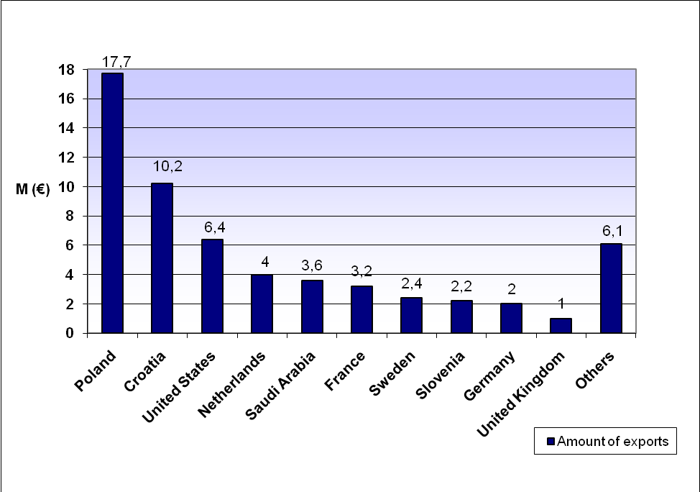

7. DEFENCE MATERIEL EXPORTS IN 2010 BY PRODUCT CATEGORY

ML  category | Number of  export licences | Value of  licences (EUR) | Value of actual  exports (EUR) | Share of total  actual exports %
1 | 52 | 18 154 486,00 | 1 188 007,00 | 2,02 %
2 | 2 | 79 800,00 | 213 031,00 | 0,36 %
3 | 68 | 22 453 543,00 | 6 816 358,00 | 11,60 %
4 | 7 | 720 784,00 | 1 628 458,00 | 2,77 %
5 | - | - | - | 0,00 %
6 | 5 | 6 216 256,00 | 27 949 730,00 | 47,56 %
7 | 58 | 889 638,00 | 3 584 368,00 | 6,10 %
8 | 18 | 2 868 468,00 | 2 495 014,00 | 4,25 %
9 | - | - | - | 0,00 %
10 | 3 | 1 609 739,00 | 2 519 812,00 | 4,29 %
11 | 21 | 1 937 279,00 | 9 724 345,00 | 16,55 %
12 | - | - | - | 0,00 %
13 | 99 | 3 791 538,00 | 770 808,00 | 1,31 %
14 | - | - | - | 0,00 %
15 | 3 | 803 000,00 | 1 064 464,00 | 1,81 %
16 | - | - | - | 0,00 %
17 | - | - | - | 0,00 %
18 | - | - | - | 0,00 %
19 | - | - | - | 0,00 %
20 | - | - | - | 0,00 %
21 | 3 | 1 548 000,00 | 811 622,00 | 1,38 %
22 | 2 | 146 900,00 | - | 0,00 %
TOTAL | 341 | 61 219 431,00 | 58 766 017,00 | 100,00 %

8. DEFENCE MATERIEL EXPORTS IN 2010 BY PRODUCT (M €)

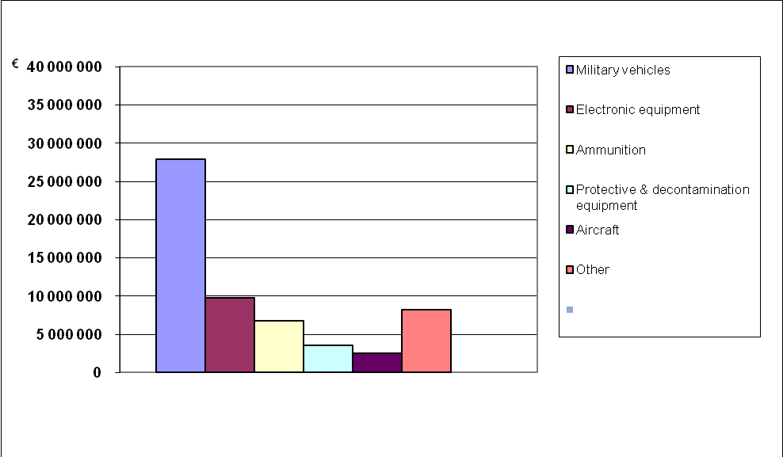
9. DEFENCE MATERIEL EXPORTS AND VALUE OF THE LICENCES
IN YEARS 2002-2010 (M €)
*
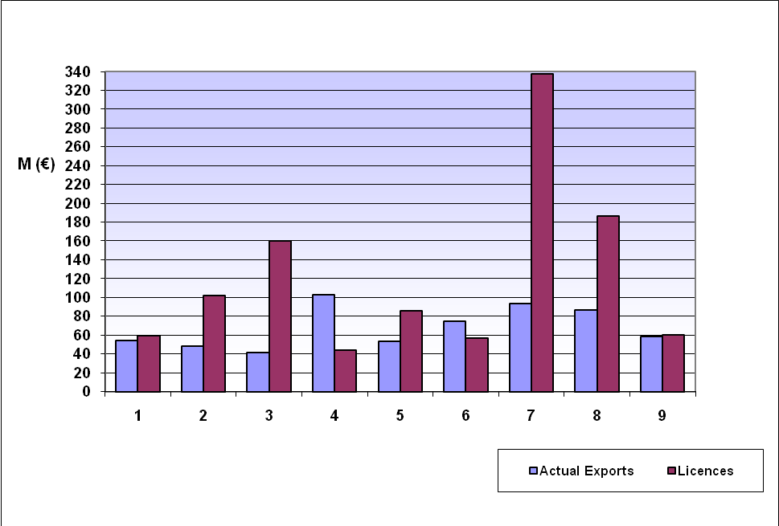

Year | Actual Exports | Licences
2002 | 54,00 | 59,40
2003 | 48,56 | 102,27
2004 | 41,59 | 160,00
2005 | 103,10 | 44,03
2006 | 53,44 | 85,89
2007 | 74,74 | 56,53
2008 | 93,26 | 337,26
2009 | 86,84 | 186,61
2010 | 58,77 | 60,3

10. BRIEF DESCRIPTIONS OF EU COMMON MILITARY LIST CATEGORIES

For the full Common Military List of the European Union, see Official Journal of the European Union C 66 of
19 March 2007
ML1 Smooth-bore weapons with a calibre of less than 20 mm, other arms and automatic weapons
with a calibre of 12,7 mm (calibre 0,50 inches) or less and accessories, and specially designed
components therefore.
ML2 Smooth-bore weapons with a calibre of 20 mm or more, other weapons or armament with a
calibre greater than 12,7 mm (calibre 0,50 inches), projectors and accessories, and specially
designed components therefore.
ML3 Ammunition and fuze setting devices, and specially designed components therefore.
ML4 Bombs, torpedoes, rockets, missiles, other explosive devices and charges and related
equipment and accessories, specially designed for military use, and specially designed
components therefore.
ML5 Fire control, and related alerting and warning equipment, and related systems, test and
alignment and countermeasure equipment, specially designed for military use, and specially
designed components and accessories therefore.
ML6 Ground vehicles and components.
ML7 Chemical or biological toxic agents, "tear gases", radioactive materials, related equipment,
components, materials and "technology."
ML8 "Energetic materials", and related substances.
ML9 Vessels of war, special naval equipment and accessories, and components therefore, specially
designed for military use.
ML10 "Aircraft", unmanned airborne vehicles, aero-engines and "aircraft" equipment, related
equipment and components, specially designed or modified for military use.
ML11 Electronic equipment, not controlled elsewhere on the EU Common Military List, specially
designed for military use and specially designed components therefore.
ML12 High velocity kinetic energy weapon systems and related equipment, and specially designed
components therefore.
ML13 Armoured or protective equipment and constructions and components.
ML14 Specialised equipment for military training or for simulating military scenarios, simulators
specially designed for training in the use of any firearm or weapon controlled by ML1 or ML2, and
specially designed components and accessories therefore.
ML15 Imaging or countermeasure equipment, specially designed for military use, and specially
designed components and accessories therefore.
ML16 Forgings, castings and other unfinished products the use of which in a controlled product is
identifiable by material composition, geometry or function, and which are specially designed for
any products controlled by ML1 to ML4, ML6, ML9, ML10, ML12 or ML19.
ML17 Miscellaneous equipment, materials and libraries, and specially designed components
therefore.
ML18 Equipment for the production of products referred to in the EU Common Military List.
ML19 Directed energy weapon systems (DEW), related or countermeasure equipment and test
models, and specially designed components therefore.
ML20 Cryogenic and "superconductive" equipment, and specially designed components and
accessories therefore.
ML21 "Software" specially designed or modified for the "development", "production" "use" of
equipment or materials controlled by the EU Common Military List.
ML22 "Technology" for the "development", "production" or "use" of items controlled in the EU
Common Military List, other than that "technology" controlled in ML7.

